

EJERCICIO 5 CON SIDEBAR Flexbox

Alumno | Carlos Daniel Garfio Murillo
Matricula | 1117150109
Materia | Desarrollo De Aplicaciones Web
Maestro | M.G.T.I. Blanca Estela Chavarria Salinas
Fecha | 10 de noviembre de 2021
Grupo | ITI91N

Index.html
<!DOCTYPE html>
<html lang="en">
<head>
<meta charset="UTF-8" />
<meta http-equiv="X-UA-Compatible" content="IE=edge" />
<meta name="viewport" content="width=device-width, initial-scale=1.0" />
<title>Ejercico 7</title>

<link rel="stylesheet" href="./css/estilos.css" />
</head>
<body>
<div class="contenedor con-sidebar">
<article class="articulo">
<h1>Titulo Imagen</h1>
<img src="https://via.placeholder.com/500" alt="" srcset="" />
<p>
Lorem ipsum dolor sit amet consectetur adipisicing elit. Consequatur
laudantium provident asperiores veritatis sequi reiciendis in laborum
aspernatur mollitia laboriosam numquam assumenda accusantium minima
nulla, rem illum enim neque consequuntur? Eveniet dicta voluptatibus
eligendi, quia ad cum deleniti nesciunt, ullam unde voluptate
inventore et laboriosam laudantium reprehenderit, dolorum dolores nam
id at necessitatibus quibusdam? Commodi assumenda ipsum a in at.
</p>
<p>
Lorem ipsum dolor sit amet consectetur adipisicing elit. At maiores
consequuntur optio nisi, eum nesciunt reprehenderit, magnam aperiam
accusamus odio culpa dicta quo dolorum sequi facere mollitia
similique? Cum, suscipit? Nisi magni sunt minima, tempore temporibus
aut. Architecto ex eum suscipit reprehenderit repellat ea illum unde
pariatur provident sit! Quas officia minus qui minima voluptate quam
in? Modi, dolore natus!
</p>
</article>
<aside>
<h1>Sobre Nosotros</h1>
<p>
Lorem ipsum dolor sit amet consectetur adipisicing elit. In,
distinctio alias beatae recusandae debitis ducimus dolor eius
laudantium officiis necessitatibus quos dicta eveniet eligendi libero,
commodi quam sint aliquid ratione.
</p>
<h1>Mision</h1>
<p>
Lorem ipsum dolor sit amet consectetur adipisicing elit. In,
distinctio alias beatae recusandae debitis ducimus dolor eius
laudantium officiis necessitatibus quos dicta eveniet eligendi libero,
commodi quam sint aliquid ratione.
</p>
</aside>
</div>
</body>
</html>

CSS
@import url("https://fonts.googleapis.com/css2?family=Poppins:wght@400;700&display=swap");

*,
*::before,
*::after {
box-sizing: border-box;
margin: 0;
padding: 0;
}

body {
font-family: Poppins, sans-serif;
font-weight: 500;
}

img {
max-width: 100%;
}

h1 {
font-size: 4rem;
}

.contenedor {
max-width: 1200px;
width: 95%;
margin: 0 auto;
}

.articulo {
display: inline-block;
background-color: #9cb3ca;
color: #ffffff;
padding: 10px 20px;
text-decoration: none;
font-weight: bold;
text-transform: uppercase;
}

.con-sidebar {
display: flex;
justify-content: space-between;
gap: 2rem;
}

/* Extra small devices (phones, 600px and down) */
@media only screen and (max-width: 600px) {
}

/* Small devices (portrait tablets and large phones, 600px and up) */
@media only screen and (min-width: 600px) {
}

/* Medium devices (landscape tablets, 768px and up) */
@media only screen and (min-width: 768px) {
aside {
flex: 0 0 calc(33.3% - 1rem);
}

article {
flex: 0 0 calc(66.6% -1rem);
}
}

/* Large devices (laptops/desktops, 992px and up) */
@media only screen and (min-width: 992px) {
}

/* Extra large devices (large laptops and desktops, 1200px and up) */
@media only screen and (min-width: 1200px) {
}

Resultados
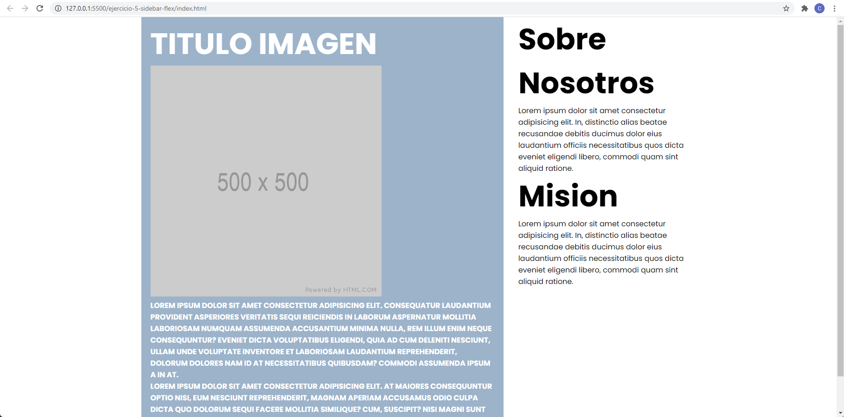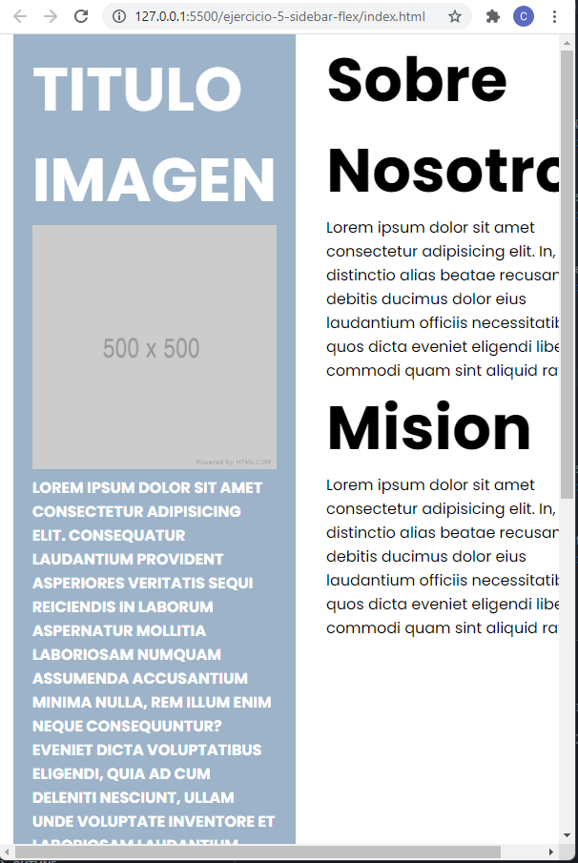
Codigo Fuente
https://github.com/CarlosGarfio/Desarrollo-de-Aplicaciones-Web

